Applying at

Genesis HealthCare System

We are VERY excited you are interested in applying for a position with our organization. Please follow the steps below to register and apply on our Career Site. Should you run into any issues at all during this process, please feel free to call the Human Resources office at 740-454-4601. Our office is open Monday-Friday from 7:30am-4pm.
- Go to www.genesishcs.org/careers
  - This page provides lots of additional information on our Employee Benefits, our Community, and our Nursing Incentives.

- To find your next opportunity with our organization, click on the View current job openings link.
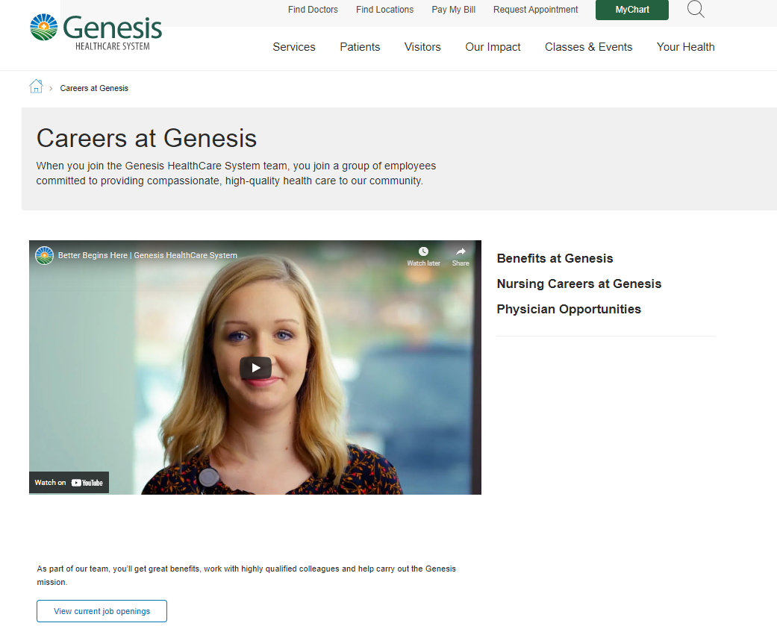

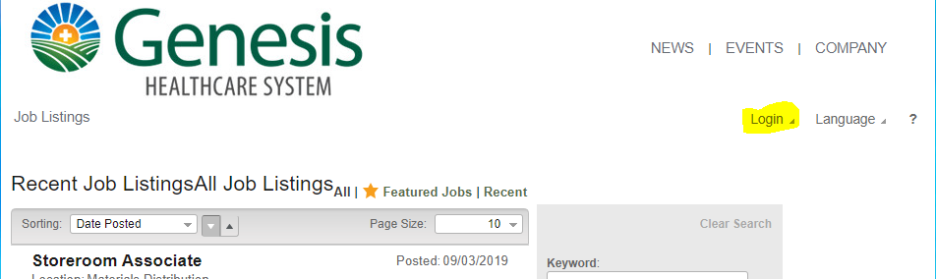
- Click “Login”

- This will bring you to the WELCOME Candidate screen.
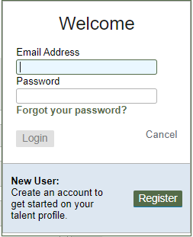
  - Already have an account with us: Log in with your username and password (REMEMBER: your username is your full email address).

  - Don’t have an account with us: No Problem! Click the “REGISTER” button to create a candidate account with us.
    - Follow the prompts on the register screen to complete your account registration.

- Once logged into your account, search the job postings to find your opportunity.

- Open the job posting to review the job description and position requirements. If the position is still of interest after reviewing that information, click the “APPLY NOW” button. This is located at the top of the job posting.

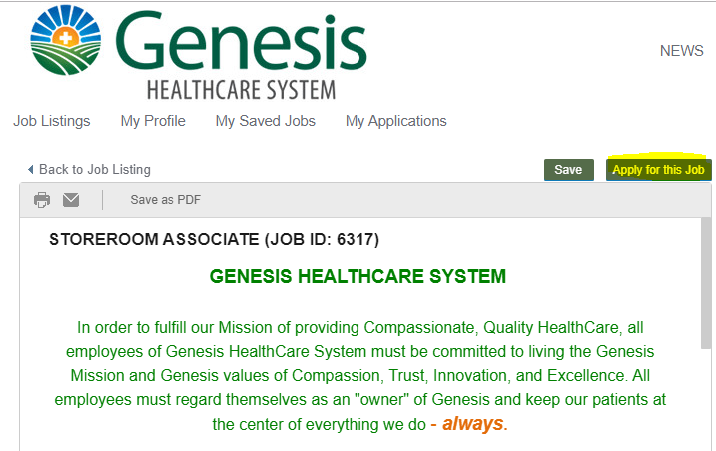

- Once you have clicked “APPLY NOW”, you will be taken to our online application. Follow the prompts on the screen to walk through all sections of our application. Please keep a couple things in mind while completing your online application:
  - Please remember to fill out the personal information section so we know how to reach you regarding your application.

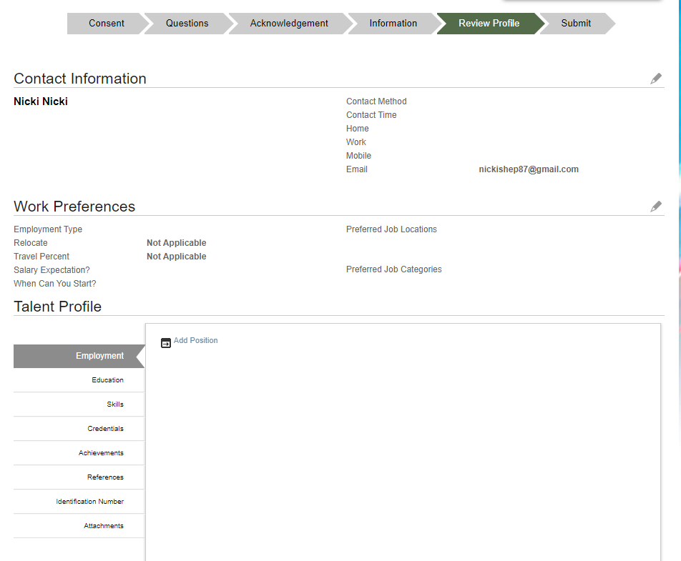
  - You must complete the application in its entirety. This includes providing at least one education record and at least three professional references.

    - If you didn’t complete the Talent Profile section during your registration, you can add Employment History, Education, Credentials, etc by clicking the sections listed under the Talent Profile header.

  - Remember: This is the only information that will be reviewed when making a decision on who to interview. Make sure your application provides as much information as possible.

- Last step of the application process is SUBMITTING your application. You must click the green Submit button for your application to be sent to the HR department for review.
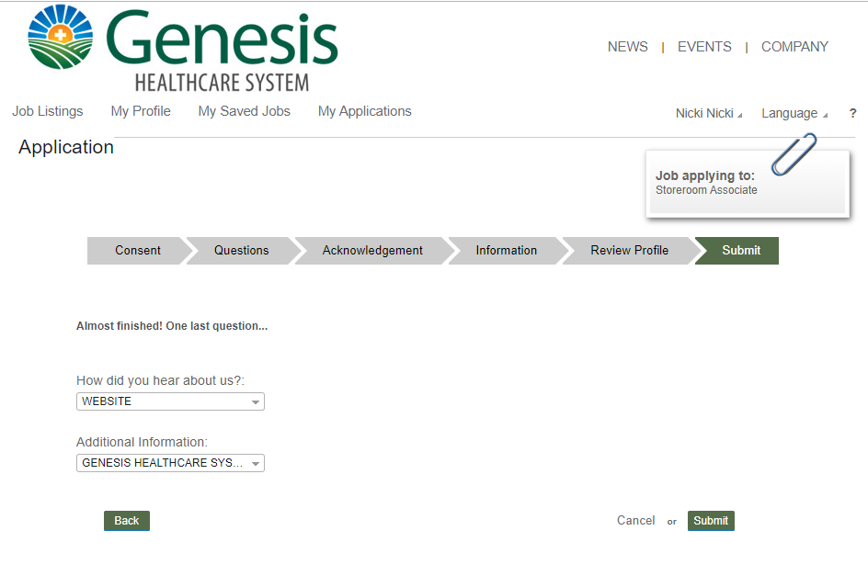

- CONGRATULATIONS! You have applied for an opportunity with our organization! You will receive an email notification once your application has been submitted. Please remember to check your email throughout the application process.

Checking the status of your application

You may always check on the status of your application by logging into your account and clicking the My Applications option at the top of the page. This will list all positions you have applied for within our organization and let you know the status of each.
